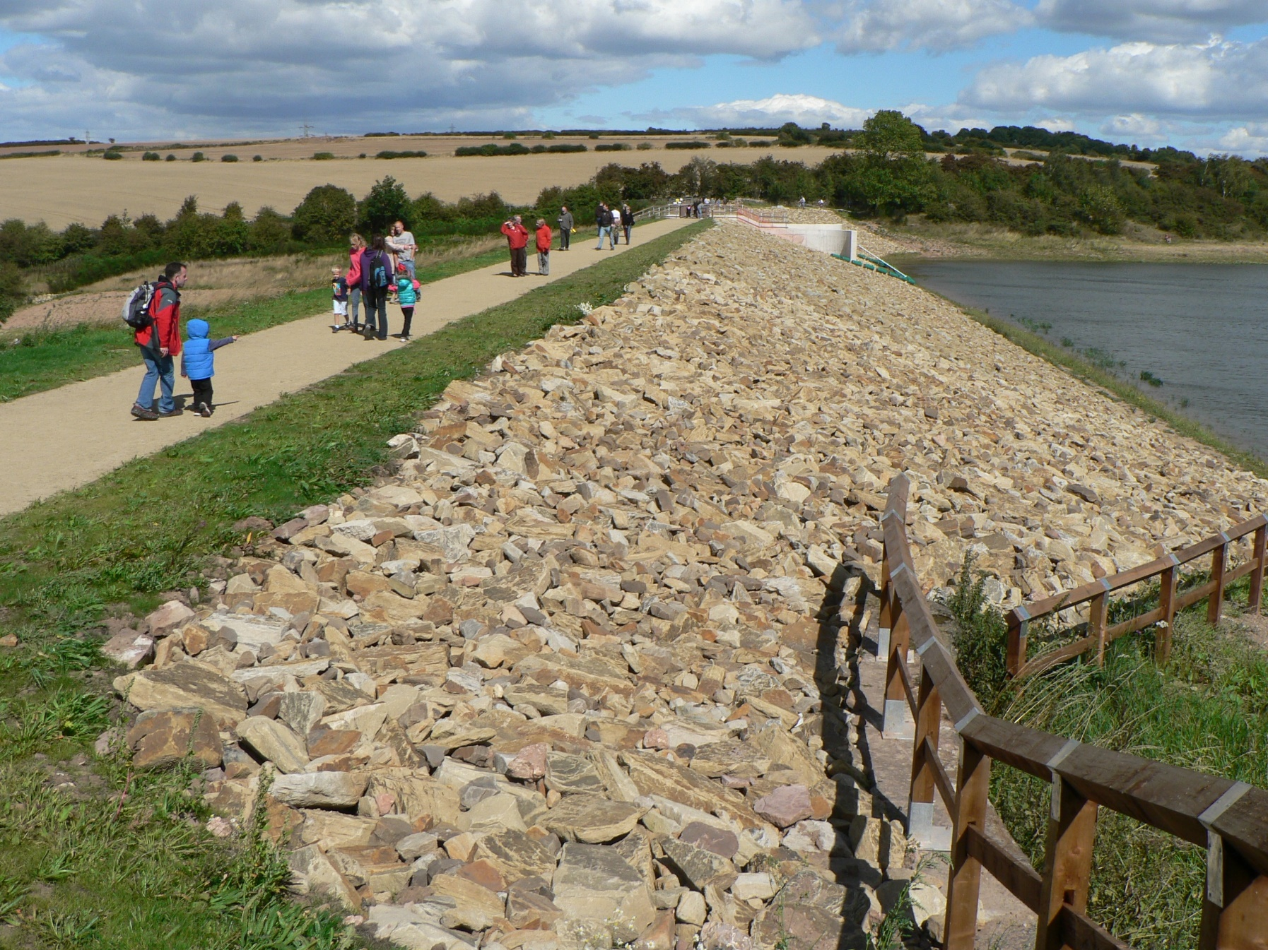
Improving the Future Supply of Reservoir Engineers – Call for Evidence

Consultation Response Form

About this form

This form is to be used to respond to the consultation document Improving the Future Supply of Reservoir Engineers – Call for Evidence published by ICE on 3 May 2022.

Deadline for submissions: 30 June 2022

Please return via email to: reservoirs@ice.org.uk

Before submitting this form, please complete the following:
Name:
Organisation:
Job Title:
Category of Consultee  I am responding as (delete as appropriate): | - A member of the Supervising Engineers Panel  - A member of the All Reservoirs Panel  - A government department  - A regulator  - An engineering firm  - A reservoir owner  - A water company  - An association, professional institution  - A private individual  - Other (please detail)
Contact Email address (optional)

Consent to sharing information
ICE will use the information you have submitted to inform a research report that is being commissioned by the Department for Environment, Food & Rural Affairs (DEFRA) and will be published in the public domain. ICE will not share your personal details publicly.
ICE will share your response to the consultation questions as well as the Category of Consultee with DEFRA as part of the research process and may also use this information in the published outputs.
ICE will not share your name, job title, employer or contact details with DEFRA without your consent.
I understand that ICE will share my response to the consultation questions as well as the Category of Consultee with DEFRA as part of the research process and may also use this information in the published outputs. | ☐
General Data Protection Regulation (GDPR)
The Institution of Civil Engineers and Thomas Telford Ltd maintain data on all members. We also maintain data on non-members who use our services. This will be used confidentially for normal purposes, including subscription and donation collection, mailing of publications, contract fulfilment when purchasing TTL products and services and notification of conferences and events.

Personal data relating to ICE membership may be stored securely in perpetuity for historical purposes. Personal data relating to non-members and/or TTL customers will only be held for as long as needed to fulfil the purpose for which it was collected.

For more information on how and why we collect and use personal data and your rights as an individual please review the ICE Privacy Notice.

Consultation Response

Please read the corresponding document, Improving the Future Supply of Reservoir Engineers – Call for Evidence and then answer the question below which are relevant to you as a consultee.

When responding to the questions please refer to the corresponding discussion points in section h) Issues for the Call for Evidence of the corresponding document, Improving the Future Supply of Reservoir Engineers – Call for Evidence

1. The scale of future demand for Panel Engineers services
- Can you provide any evidence that will help the review better understand the scale of future demand for Panel Engineers services, including the pattern of future changes to demand for the Construction Engineer, Inspecting Engineer and Supervising Engineer roles?
- What are the key uncertainties the review should consider?

Question 1 response:

2. The ability of all reservoir owners to access the services of Panel Engineers

- Can you provide any evidence that will help the review demonstrate the current and potential future availability of the services of Construction, Inspecting or Supervising Engineers to all sizes of reservoir owner?
Question 2 response:

3. The impact of the commercial environment on investment by consultancy businesses in the development of future Panel Engineers

- Would you be willing to share in confidence any evidence on the risk/reward balance for your business of carrying out ARPE and SE work?
- Do you have any evidence that will help us demonstrate the impact of the current commercial environment on the ability and willingness of your businesses to continue to develop Supervising Engineers and All Reservoir Panel Engineers?
- Do you have any evidence to support the view that clients will be willing to increase fees to reflect:
- A shortage of supply of Panel Engineers
- An increased recognition of the value delivered by high quality ARPE and SE work
- Do you have any views or evidence on the benefits and disadvantages of delivering ARPE Section 10 inspections through a possible Independent Inspectorate that set standardised fees?
- Do you have any views on how such an inspectorate could be designed, managed and funded?
- Do you have any views on the desirability and feasibility of reservoir owners and consultancy businesses establishing a sector level agreement or mechanism to establish standard fee rates?
Question 3 Response:

4. The role of collaboration and resource sharing between Water Companies in easing pressure on Panel Engineer resources
- How might it be possible for Water Companies to collaborate to increase the supply of Panel Engineers and make better use of existing resources?
- What impact would an enhanced water company role have on the ability of consultancy businesses to continue developing ARPEs and SEs?
Question 4 Response

5. The future panel structure
- How could the number and structure of Panels evolve to improve the supply and utilisation of Panel Engineers?
- In the event of a change, what would be your preferred panel structure and why?
- How could any risks be mitigated?
Question 5 Response

6. A structured development pathway and training for prospective All Reservoir Panel Engineers

- What action can be taken to help prospective All Reservoir Panel Engineers access construction supervision and design experience.
- What role can better communication of the range of works the Reservoir Committee accepts as relevant construction play in solving this problem?
- Do you agree that the Reservoir Committee should create a structured support and guidance package that sets out a pathway to support SEs develop and demonstrate achievement of the attributes needed for appointment to the All Reservoirs Panel?
- What role could such a codified pathway play in opening the sector to qualified civil engineers from other disciplines
- Do you or your organisation have any materials or processes that could contribute to such a package?
- What role could a formal training course place in this package? How could such a course be funded and delivered?
Question 6 Response

7. The ARPE Interview

- What has driven the improved pass rate over the last 5 years for candidates presenting for interview for the first time for the All Reservoirs Panel?
- How can the effectiveness and perceived fairness of the interview process be further improved
- How can the pre, during and post interview experience of candidates be improved
Question 7 Response

8. Diversity

What can be done to improve the extremely low diversity of the membership of the Reservoir Panels

Question 8 Response

Our vision
Civil engineers at the heart of society, delivering sustainable development through knowledge, skills and professional expertise.
Core purpose
- To develop and qualify professionals engaged in civil engineering
- To exchange knowledge and best practice for the creation of a sustainable and built environment
- To promote our contribution to society worldwide
Diversity statement
As a membership organisation and an employer, we value diversity and inclusion - a foundation for great engineering achievement

Institution of Civil Engineers
One Great George Street
Westminster
London SW1P 3AA
UK

T: +44 (0) 20 7665 2012
E: membership@ice.org.uk
W: ice.org.uk

Institution of Civil Engineers is a Registered Charity in England & Wales (no 210252) and Scotland (SC038629).

